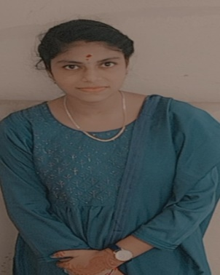**SKILLS**

**Soft Skill** Basic python

Basic computer

**EDUCATION**

|  |  |  |  |  |
| --- | --- | --- | --- | --- |
| Degree/Course | Institute/College | University/  Board | Percentage/  CGPA | Year of passing |
| SSLC | Government girls higher secondary school | State board | 88% | 2018- 2019 |
| HSC | Government girls higher secondary school | State board | 89% | 2020-2021 |
| BSc. Computer science | AGAC | State board |  | 2021-present |

**HOBBIES**

Work on IT

**PERSONAL DETAILS**

Address : 97,indiranagar 6th street, Aranthangi, pudukkottai(dt)

Date of Birth : 16/06/2004

Gender : Female

Nationality : Indian

Religion : Hindu

Marital Status : Single

Languages known : Tamil, English

**DECLARATION**

I hereby declare that all the details furnished here are true to the best of my knowledge and belief .I promise to work sincerely and prepare to work duty ability to organization.

Date: 26:04:2023

Place: Karaikudi K.Ishwarya